IPv6期末報告

題目： IPv6之檔案傳輸

系級：電機四
組員：石鵬
李定謙
陳家榮
羅文廷

前言：
我們這組做的東西，簡單來說就是透過IPv6的網路，來進行檔案間傳輸。不過因為當初沒考慮太多，所以只能兩端都是v6的address進行通訊，沒辦法一端使用v4、一端使用v6來傳輸檔案。

使用軟體：sever與client的程式都是在Windows XP上使用Microsoft Visual C++ 2008 Express Edition進行程式的撰寫。至於呈現的方式，是使用命令提示字元開啟exe檔進行檔案傳輸。

以下為程式碼：

Sever：
#include <sys/types.h>
#include <stdio.h>
#include <winsock2.h>
#include <ws2tcpip.h>
#include <stdio.h>
#include <process.h>
#define GET 1
#define PUT 2
#define DELAY 0 //單位1ms 1ms
unsigned char buffer[0x1000000]; //設定檔案大小上限為16MB

int main(){
char filename[80];
int filelength, tmplen, len;
FILE *fp;
int server_sockfd, client_sockfd;
int server_len, client_len;
int ret;
struct sockaddr_in6 server_address;
struct sockaddr_in6 client_address;
WSADATA wsaData;
WSAStartup(MAKEWORD(2,2),&wsaData);
server_sockfd = socket(AF_INET6, SOCK_STREAM, 0);

server_address.sin6_family = AF_INET6;
IN6ADDR_SETANY(&server_address);
server_address.sin6_addr.u.Byte[0] = 0x20;
server_address.sin6_addr.u.Byte[1] = 0x01;
server_address.sin6_addr.u.Byte[2] = 0x0e;
server_address.sin6_addr.u.Byte[3] = 0x10;
server_address.sin6_addr.u.Byte[4] = 0x68;
server_address.sin6_addr.u.Byte[5] = 0x40;
server_address.sin6_addr.u.Byte[6] = 0x00;
server_address.sin6_addr.u.Byte[7] = 0x19;
server_address.sin6_addr.u.Byte[8] = 0x02;
server_address.sin6_addr.u.Byte[9] = 0x1f;
server_address.sin6_addr.u.Byte[10] = 0x3b;
server_address.sin6_addr.u.Byte[11] = 0xff;
server_address.sin6_addr.u.Byte[12] = 0xfe;
server_address.sin6_addr.u.Byte[13] = 0x7f;
server_address.sin6_addr.u.Byte[14] = 0xa5;
server_address.sin6_addr.u.Byte[15] = 0xd5;
// server_address.sin6_scope_id = 4;
server_address.sin6_port = 9734;
server_len = sizeof(server_address);
ret = bind(server_sockfd, (struct sockaddr *) &server_address,
server_len);

while(1){
char ch[64];
int i;
printf("server waiting\n");
listen(server_sockfd, 5);

client_len = sizeof(client_address);
//accept() 接受Client連線要求。建立socket 欄位中的remote IP及Port
client_sockfd = accept(server_sockfd,
(struct sockaddr *) &client_address, &client_len);
//wait client to send PUT or GET
while ((ret=recv(client_sockfd,ch,64,0)) == -1);
printf("recv ret=%d, %s \n",ret,ch);
if (!strcmp(ch, "PUT")) { //client put file to serve
//wait client to send file name
while ((ret=recv(client_sockfd,filename,64,0)) == -1);
printf("recv ret=%d, %s\n",ret,filename);
//wait client to send file length
while ((ret=recv(client_sockfd,(char*)&filelength,64,0)) == -1);
printf("recv ret=%d, filelength %d\n",ret,filelength);
//recv file content from client
i = 0;
while (i < filelength) {
while ((ret=recv(client_sockfd,buffer+i,1024,0)) == -1);
printf("recv ret=%d bytes\n",ret);
i = i + ret;
}
printf("%d bytes has been received\n",i);
if (i != filelength)
printf("received byte number is not correct !!!!\n");
//open file and write buffer to file

if ((fp = fopen(filename,"wb")) == NULL) {
printf("%s file open error\n",filename);
exit(1);
}
i=0;
tmplen = filelength;
while (tmplen > 0) {
if (tmplen > 1024) {
fwrite(buffer+i,1,1024,fp);
i = i + 1024;
tmplen = tmplen - 1024;
}
else {
fwrite(buffer+i,1,tmplen,fp);
i = i + tmplen;
tmplen = tmplen - tmplen;
}
}
fclose(fp);
printf("%d bytes written to file\n",i);
if (i != filelength)
printf("written byte number is not correct !!!!\n");
}
else if (!strcmp(ch, "GET")) { //client get file from serve
//wait client to send file name
while ((ret=recv(client_sockfd,filename,64,0)) == -1);
printf("recv ret=%d, %s\n",ret,filename);
if ((fp = fopen(filename,"rb")) == NULL) {
printf("%s file open error\n",filename);
exit(1);
}
printf("file %s opened\n",filename);
//read file into buffer array
len = 0;
while (1) {
tmplen = fread(buffer+len, 1, 1, fp);
if (!tmplen)
break;
len += tmplen;
}
fclose(fp);
printf("file size is %d (0x%08x) bytes\n",len,len);

//send file length to client
printf("send file length %d to client\n",len);
ret=send(client_sockfd,(char*)&len,4,0);
printf("send ret=%d\n",ret);
Sleep(DELAY);
//send file content to client
i = 0;
tmplen = len;
while (tmplen > 0) {
if (tmplen > 1024) {
printf("send 1024 bytes to client\n");
ret=send(client_sockfd,buffer+i,1024,0);
printf("send ret=%d\n",ret);
i += 1024;
tmplen = tmplen - 1024;
Sleep(DELAY);
}
else {
printf("send %d bytes to client\n",tmplen);
ret=send(client_sockfd,buffer+i,tmplen,0);
printf("send ret=%d\n",ret);
i += tmplen;
tmplen = tmplen - tmplen;
}
}
printf("%d bytes has been sent to client\n",i);
if (i != len)
printf("sent byte number is not correct !!!!\n");
}
}
}
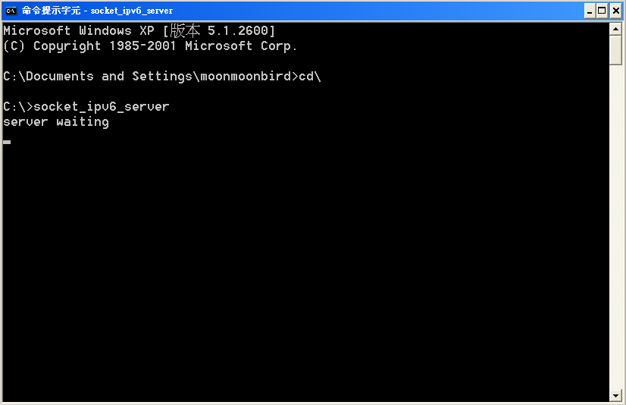

Client：
#include <sys/types.h>
#include <stdio.h>
#include <winsock2.h>
#include <ws2tcpip.h>
#include <stdio.h>
#include <process.h>
#define GET 1
#define PUT 2
#define DELAY 0 //單位1ms
unsigned char buffer[0x1000000]; //設定檔案大小上限為16MB

//first argument: "get" or "put"
//second argument: filename to get or to put
int main(int argc, char* argv[]){
int type;
char filename[80];
FILE *fp;
int sockfd;
int len,i,tmplen, filelength;
struct sockaddr_in6 address;
int ret;
WSADATA wsaData;

if (argc < 3) {
printf("Please use ftclient get filename or ftclient put filename\n");
exit(0);
}
if (!strcmp(argv[1], "get"))
type = GET;
else if (!strcmp(argv[1], "put"))
type = PUT;
else {
printf("Please use ftclient get filename or ftclient put filename\n");
exit(1);
}
strcpy(filename,argv[2]);

WSAStartup(MAKEWORD(2,2),&wsaData); /* initilizing Windows Socket */

sockfd = socket(AF_INET6, SOCK_STREAM, 0);

address.sin6_family = AF_INET6;
IN6ADDR_SETANY(&address);
address.sin6_addr.u.Byte[0] = 0x20;
address.sin6_addr.u.Byte[1] = 0x01;
address.sin6_addr.u.Byte[2] = 0x0e;
address.sin6_addr.u.Byte[3] = 0x10;
address.sin6_addr.u.Byte[4] = 0x68;
address.sin6_addr.u.Byte[5] = 0x40;
address.sin6_addr.u.Byte[6] = 0x00;
address.sin6_addr.u.Byte[7] = 0x19;
address.sin6_addr.u.Byte[8] = 0x02;
address.sin6_addr.u.Byte[9] = 0x1f;
address.sin6_addr.u.Byte[10] = 0x3b;
address.sin6_addr.u.Byte[11] = 0xff;
address.sin6_addr.u.Byte[12] = 0xfe;
address.sin6_addr.u.Byte[13] = 0x7f;
address.sin6_addr.u.Byte[14] = 0xa5;
address.sin6_addr.u.Byte[15] = 0xd5;
// address.sin6_scope_id = 4;
address.sin6_port = 9734;
len = sizeof(address);

ret = connect(sockfd, (struct sockaddr *) &address, len);

if(ret == -1){
perror("oops : client");
exit(1);
}

if (type == PUT) {
if ((fp = fopen(filename,"rb")) == NULL) {
printf("%s file open error\n",filename);
exit(1);
}
printf("file %s opened\n",filename);
//send "PUT" to server
printf("send PUT to server\n");
ret=send(sockfd,"PUT",4,0);
printf("send ret=%d\n",ret);
Sleep(DELAY);
//send filename to server
printf("send filename %s to server\n",filename);
ret=send(sockfd,filename,strlen(filename)+1,0);
printf("send ret=%d\n",ret);
Sleep(DELAY);
//read file into buffer array
len = 0;
while (1) {
tmplen = fread(buffer+len, 1, 1, fp);
if (!tmplen)
break;
len += tmplen;
}
fclose(fp);
printf("file size is %d (0x%08x) bytes\n",len,len);
//send file length to server
printf("send file length %d to server\n",len);
ret=send(sockfd,(char*)&len,4,0);
printf("send ret=%d\n",ret);
Sleep(DELAY);
//send file content to server
i = 0;
tmplen = len;
while (tmplen > 0) {
if (tmplen > 1024) {
printf("send 1024 bytes to server\n");
ret=send(sockfd,buffer+i,1024,0);
printf("send ret=%d\n",ret);
i += 1024;
tmplen = tmplen - 1024;
Sleep(DELAY);
}
else {
printf("send %d bytes to server\n",tmplen);
ret=send(sockfd,buffer+i,tmplen,0);
printf("send ret=%d\n",ret);
i += tmplen;
tmplen = tmplen - tmplen;
}
}
printf("%d bytes has been sent to server\n",i);
if (i != len)
printf("sent byte number is not correct !!!!\n");

}
else if (type == GET) {
//send "GET" to server
printf("send GET to server\n");
ret=send(sockfd,"GET",4,0);
printf("send ret=%d\n",ret);
Sleep(DELAY);
//send filename to server
printf("send filename %s to server\n",filename);
ret=send(sockfd,filename,strlen(filename)+1,0);
printf("send ret=%d\n",ret);
Sleep(DELAY);

//wait client to send file length
while ((ret=recv(sockfd,(char*)&filelength,64,0)) == -1);
printf("recv ret=%d, filelength %d\n",ret,filelength);
//recv file content from server
i = 0;
while (i < filelength) {
while ((ret=recv(sockfd,buffer+i,1024,0)) == -1);
printf("recv ret=%d bytes\n",ret);
i = i + ret;
}
printf("%d bytes has been received\n",i);
if (i != filelength)
printf("received byte number is not correct !!!!\n");
//open file and write buffer to file
if ((fp = fopen(filename,"wb")) == NULL) {
printf("%s file open error\n",filename);
exit(1);
}
i=0;
tmplen = filelength;
while (tmplen > 0) {
if (tmplen > 1024) {
fwrite(buffer+i,1,1024,fp);
i = i + 1024;
tmplen = tmplen - 1024;
}
else {
fwrite(buffer+i,1,tmplen,fp);
i = i + tmplen;
tmplen = tmplen - tmplen;
}
}
fclose(fp);
printf("%d bytes written to file\n",i);
if (i != filelength)
printf("written byte number is not correct !!!!\n");
}
exit(0);
}
註：前一個x表檔案名稱，後一個x表檔案格式
Put：client傳檔案給sever
Get：client跟sever要檔案

因為當初寫程式的時候，是把sever端的IP address寫死在裡面，所以如果是透過區域網路進行檔案傳輸時，需更改IP為fe80::21d:72ff:fe35:c1f2，並加入scope id：5；而透過無線網路進行傳輸，就須把IP改為global IP：2001:e10:6840:19:021f:3bff:fe7f:a5d5。這點也是我們在課堂上demo時，為什麼會失敗的原因。
另外，經由觀察檔案傳輸在有線網路與無線網路的傳輸中，發現到：透過有線網路傳輸時，它傳輸速度都是固定的1024(byte/s)，符合程式中所設定的。但在無線網路傳輸中，會做fragmentation，拆成固定兩個大小的速度，所以在實驗室demo的時候，在接收檔案那端的速度會一直以1024、608、416重複下去直到檔案傳輸完成。

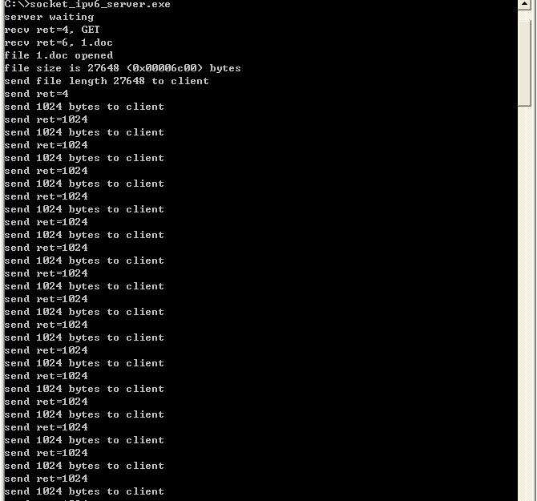
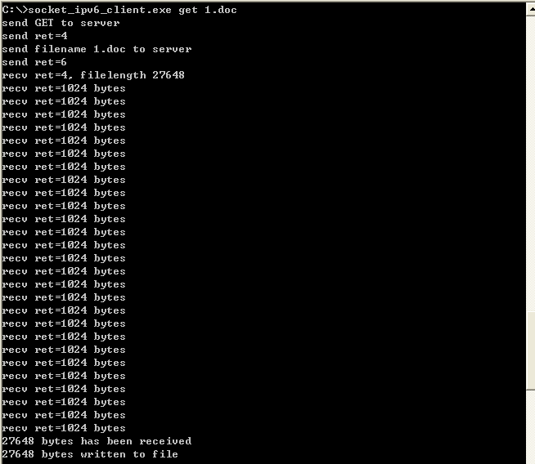
期末實作未能符合老師所要求的「加入倒數時間，若在時間內有一個以上client要檔案，則使用multicast進行檔案傳輸」；但由於程式火侯未到，所以目前最多只能完成一個client與sever之間的傳輸。希望上面的程式碼能給明年修這門課的同學ㄧ點幫助，站在巨人的肩膀上，才可以看的更遠。

